Troy Jeffery

Shelly Griffin

Writing 121

Friday, April 12, 2019

The Basement: Although There Are Many Like It, This One Is Mine

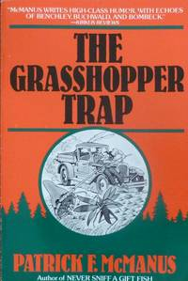As a young child growing up I was introduced to the author Patrick McManus. McManus writes stories about his life growing up in the Pacific Northwest. Far from the semi realistic style of books like “The Hatchet” by Gary Paulson, these stories were wild and over the top semi-fictional accounts of things that had happened to him. I remember, sitting in the cramped gymnasium of the La Grande elementary school captivated while listening to the story being told. Sitting a few inches closer to the speaker than allowed, I remember being temporarily removed from the immersion that only excellent story tellers are capable of crafting. “What will my stories be?” I wondered. With the kind of unwavering confidence only afforded to the young, I answered “It will come sometime before I grow up.”

At the time I didn’t realize that the grand adventures McManus was describing weren’t the result of a remarkably accurate historical event. Rather, this time-tested sage was reliving his past using the child inside all of us as his conduit. The mistake it would take me more than two decades to recognize is that by waiting for these experiences to arrive caused me to miss a great many of them. Youth is truly wasted on the young. If there’s one thing to be learned from McManus it’s that these experiences are only as far away as your inner child. With that being said, allow my youthful passenger the chance to relive a day from my past.

A story from this book was read to me in 3rd grade. It was the inspiration for this story.

I had just arrived home from a summer long missionary trip with my grandparents in England when I got the news. We’re moving again, before the end of the week. This sort of thing, fairly common in my childhood, made me thankful that I hadn’t really made any friends over the previous year. So, like a tumbleweed in the wind, my destiny brought me the rickety little house located somewhere in the middle of Hick Ville that was referred to as Baker City.

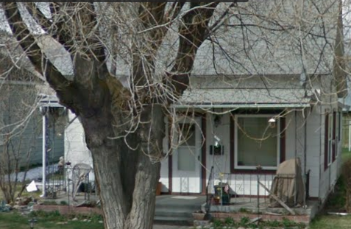The house at first glance was a little…meh. Well and second glance and third glance… But don’t be fooled by this old dusty book cover, the beauty was on the inside. My mother gave me a mercifully brief tour of the one bedroom, one-bathroom manor we had come to inhabit which left only one question, “Which room is mine?” Wielding a grin, mom led me back into the kitchen area where there was a door that had previously been left closed. As she opened it, I was greeted for the first time with that cool musty air that would come to be like a brother’s embrace.

Home Sweet Home!

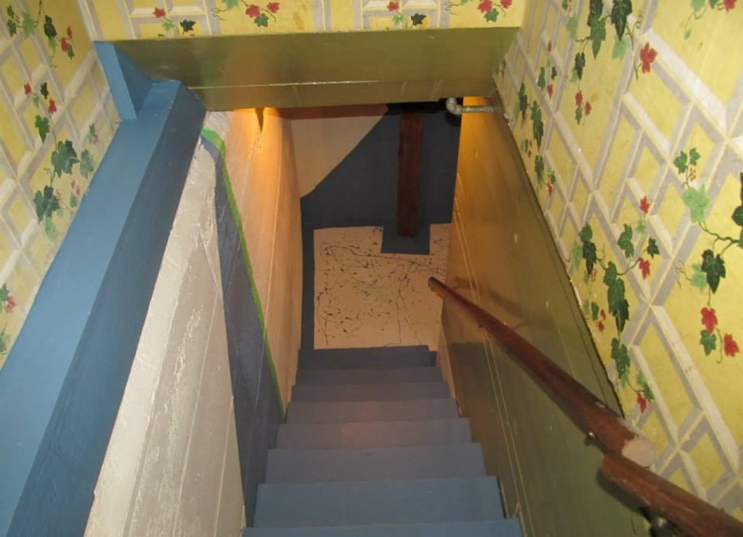Admittedly, it was a little rough around the edges. The stairs were perceptibly steep and there was some sort of protrusion that caused you to either have to duck or lean back. If it had been a few years later I’m sure I would have thought of Neo’s scene in the matrix where he leans back to dodge bullets, but this was all before Y2K was even a thing.

Sketchy steps (Post Remodel), Dodge This!

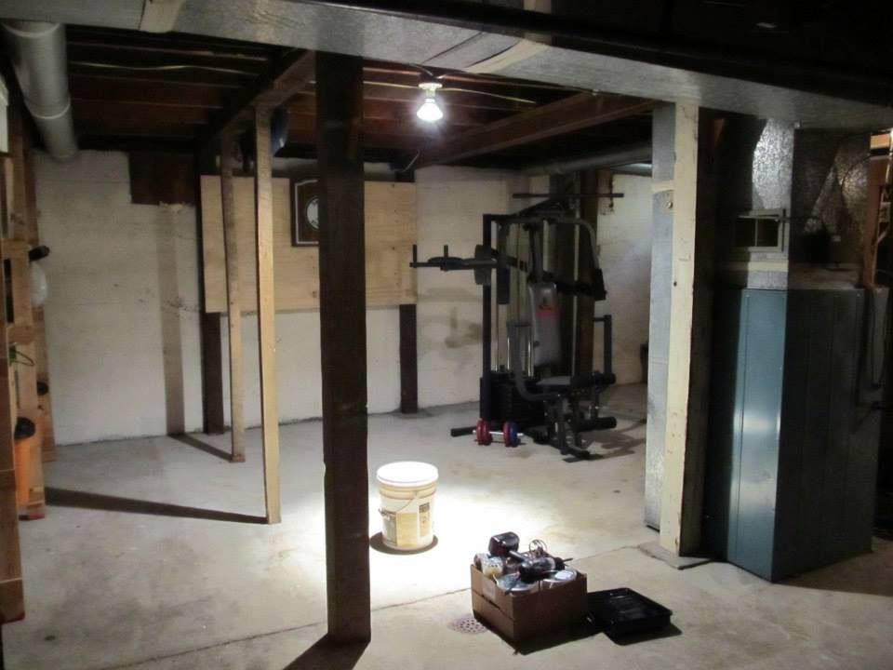Once you got past the stairs the completely concrete floor was a little “hard” to look past and there were exposed pipes where a ceiling should have been. Structurally, the house was…old. This meant that there were beams throughout the basement that would serve as a constant nemesis during my occupation. Besides being inconveniently placed so they could structurally secure the floor, accidently bumping into one had a “gong” like effect on the rest of the house. I’m not afraid to admit that I’m more than a little clumsy which did not serve me well when I stayed up well into the night. The room was not the only thing still needing a little smoothing.

Concrete (Bottom), Beams (Left), Pipes (Top), Heater (Right)

Now, before I continue, you must understand that I have a medical issue known loosely in the medical community as “bugaphobia”. This means that at the slightest glimpse of an insect of any sort I become terrified and fear for my physical safety. You may call if irrational, but if you saw the way the beetle looked at me you’d understand. Worse than the beetles were the spiders who made daily attempts at my life by stringing their webs in my path hoping to fell me like a giant.

My mom always told me they couldn’t hurt me and just squash them, but I couldn’t help but think they had some “insect council” somewhere. If my suspicions were correct, my crimes would be brought before the council and my fate would be decided. Insect justice may not be swift, but it is severe, and I could not risk being sentenced a “problem”. In the end we did come to an uneasy peace similar to how people walk on the subway in New York. I don’t see you, you don’t see me. Also, bug bombs are super effective for toppling insect governments.

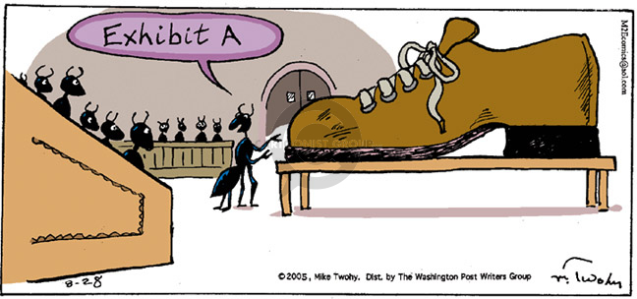

Insect Council Deciding My Fate

Another trial we had to brave was the light problem. Without it, the room was darker than the bottom of the ocean on a moonless night. We’re talking freaky dark here, like scientific anomaly dark. The sole oasis in the desert of darkness was located at the top of the stairs. This means that entering the subterranean space at night is like a blind man completing the ninja warrior obstacle course. Fortunately, I’m a bit of a tough guy as long as insects aren’t involved (I told you I have a medical condition!) so I’d been telling my parents I wasn’t afraid of the dark for years. This was mostly true, but it’s much easier to fight off nightmares with a weapon, and the only weapon I had to fight the darkness was at the top of the stairs…in the darkness.

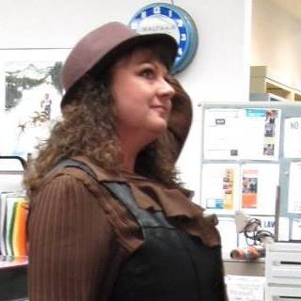One thing people never tell you about living in an old house are the sounds that the house makes as it fights gravity to stay upright. But to a boy who had just crossed into double digits and still slept with his ninja turtles’ blanket, I couldn’t help but shake the feeling that the house was losing the struggle. In the endless darkness the room engulfed you in, you could be forgiven for mistaking the creaking of the ancient structure for skeletons standing at attention, just waiting for the order to add you to their ranks. Being as tough as I was and knowing the ninja turtles would doubtless come to my aid in a pinch, I would never have thought that. But just so you know, if I did I should be forgiven.

My mom in 2016 as the Children’s Librarian

As we continued to familiarize ourselves with the labyrinth we had entered our minotaur loomed. Like an hourglass, daylight was draining from the sky and my courage was racing to keep up with it. So, when my mom asked me if I wanted her to sleep with me downstairs for the first night, it presented a serious moral crossroad. Do I risk people finding out that my mom slept with me because I was afraid of the dark? Or do I risk a house cave in as I defend myself from hordes if ravenous insects and warrior skeletons using the darkness as cover? I considered only briefly before I heard a deep rumbling behind me and felt the flicker of flames on my back. My eyes grew large as I looked at my mom in fear. No matter how tough I was, I knew that I was no match for a dragon.

My mother, never one to stifle a laugh, raised her hand to cover her mouth. She pointed behind me and said, “It’s just the heater, silly.” Relieved that there wasn’t a mythical beast hiding in my new room, but deflated at my social miscue, I begrudgingly asked my mom to provide me with her company on what was sure to be a long night….

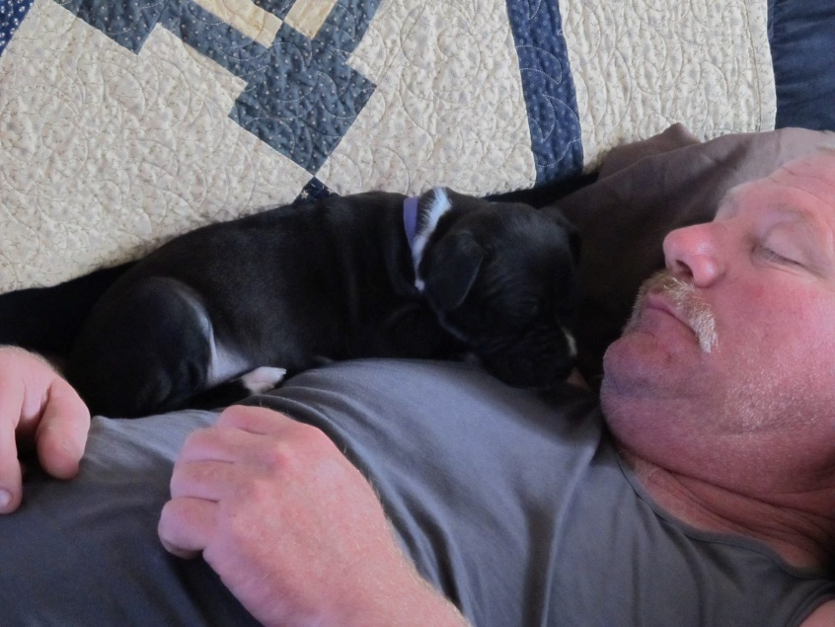As my inner child relives some of his past, I can think of dozens of stories like this. For example, my step dad, Ray, always slept on the couch. To get to the one bathroom we’d have to sneak up the stairs, through the kitchen and past the slumbering man all in the dark. Stumbling anywhere would make enough noise to wake Ray up, and he **does not** like being woken up at 3 A.M. You might say, “Why not hold it?” Well we’d go to dollar tree and buy tons of candy and soda for the weekend of course! How long can you hold in 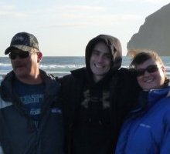the Mountain Dew before you have to go on the quest past the sleeping giant? Keep in mind the more you have to pee the harder it is to sneak!

Don't let the puppy fool you, Ray’s very scary. Don’t wake him!

Throwing up Papa Murphey’s all over the steps Christmas morning when I was 15? That’s a great story! Falling in love with audio books by listening to Hank the Cow dog? Epic! My adventures playing the text-based RPG MajorMud on dial-up? Timeless!

Ray (Left), Me (Center), Mom (Right) at the coast a number of years ago.

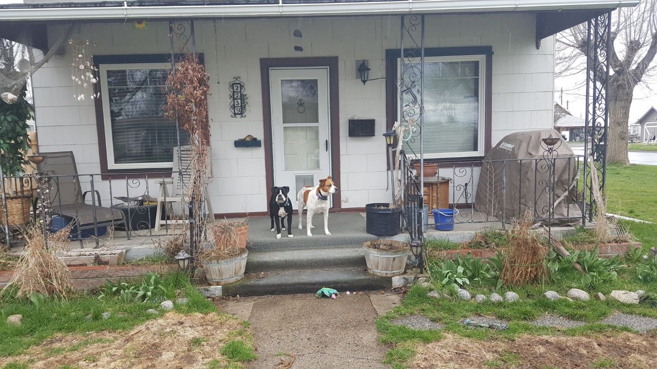What my pre-pubescent self-missed by always looking forward is that the adventure is happening in the only place he wasn’t looking; The present. Don’t be afraid to let child inside play, even if it’s just in your memories. For mine that basement is like Disneyworld. Seeing it again after it was remodeled broke my heart, but change is the undeniable nature of the universe. If life is a battlefield, the basement will always be my fallen brother in arms. What better way to honor my lost companion than to relive those memories that would otherwise be forgotten?

The house in 2019.